Official league roster - Basketball
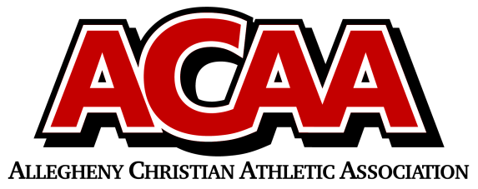

School Name: Johnstown Christian
Team Colors: Royal Blue & White
Overall Wins ___ Losses ____ Ties ___
ACAA Wins ___ Losses ____ Ties ___ OPPONENT: __________________________
Date: _________
Number | Name | Year | Position | Height | Homeschool
21 | Elijah Williams | 12 | F
33 | Sam Ribaric | 12 | F
10 | Mason Dean | 12 | G
22 | Joe Sorg | 11 | F
1 | Jaydon Yoder | 10 | G
14 | Daniel Harper | 9 | F
3 | Jeremiah Taylor | 9 | G
20 | Jonah Harr | 9 | F
5 | Matthew Blough | 9 | F
13 | Braydon Kibbi | 9 | G
11 | Nashon Timazee | 9 | G

Head Coach: Andrew Taylor
Asst. coach: Hunter Thomas
Asst. coach:

Official ACAA League Team Roster. to be submitted to the scorer’s table before each game.

